





Membership Standards

The Profession Map sets the international benchmark for people professionals. The Membership standards are a subset of the full professional standards and articulate the expectations for different grades of CIPD membership.

The membership standards apply to anyone coming into membership via Experience Assessment, or anyone Upgrading to Chartered Member of Chartered Fellow. They’re based on core knowledge and core behaviour areas of the map, and focus on your expertise in people, work and change, and how you contribute to the profession’s values of being principles -led, evidence based and outcomes-driven. These standards may differ slightly in wording from the full profession map.

Use these standards to determine which membership level is right for you.
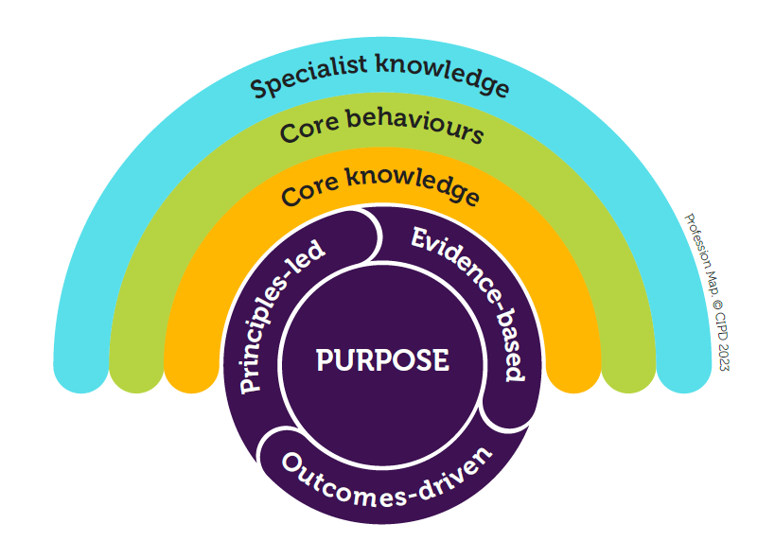

Core  knowledge  - People practice  - Culture and  behaviour  - Business acumen  - Evidence-based practice  - Technology and people  - Change | Core  behaviours  - Ethical practice  - Professional courage  and influence  - Valuing people  - Working inclusively  - Commercial drive  - Passion for learning  - Insights focused  - Situational  decision-making | Specialist  knowledge  - Employee experience  - Employee relations  - Equality, diversity and inclusion  - Learning and development  - Reward  - People analytics  - Organisation development  and design  - Resourcing  - Talent management  - Wellbeing





Core knowledge membership standards



People practice
Understanding the range of people practices needed to be an effective people professional.

People practices across a range of specialisms, and how to integrate these to create a holistic people offering

Current and future regulation and law relevant to your work, and how to assess impact and risk for organisations and industry sector

How to build equality, diversity and inclusion approaches that positively impact on an organisation’s culture and performance

Culture and behaviour
Understanding people's behaviour and creating the right organisation culture.

How systemic approaches contribute to organisation performance

Different ethical perspectives, mindsets and values, and their implications for organisation culture

Business acumen
Understanding your organisation, the commercial context and the wider world of work.

Your organisation’s long-term vision and strategy, and what it means for the people strategy

How external influences and trends impact organisation performance, and potential future trends in your sector and beyond

How people strategies create sustainable value for others, and the interdependencies and risks of those value creations

Different forms of strategy development, how to create an organisation-wide people strategy, and shape the business strategy

Future opportunities and risks in your organisation’s operating model and how to enhance competitive advantage

Evidence-based practice
Using evidence and data to create insight, problem solve, develop ideas and measure impact.

How to use business and people analytics to influence and shape strategy

How to define outcomes for people strategies and measure their short and long-term impact and value

Technology and people
Understanding the impact of technology on people at work

How current and future emerging technologies can enable people strategies and organisation performance

Change
Understanding how to effectively enable change.

How to embed a people-centred approach to change management

How to create an organisation environment and culture that is change-ready and change-capable

How to assess which levers will achieve and sustain change across an organisation, and create long term value

Core behaviours
Explore the defining behaviours
of our profession


Ethical practice
Building trust by role-modelling ethical behaviour, and applying principles and values consistently in
decision-making.

Make responsible decisions by balancing different ethical perspectives, and shape how ethics inform wider decision-making and governance

Professional courage and influence
Showing courage to speak up and skilfully influencing others to gain buy in.

Take a stand with senior colleagues when it is the right thing to do despite significant opposition or challenge

Use a wide range of influencing styles and strategies to secure commitment across and outside your organisation

Valuing people
Creating a shared purpose and enabling people development, voice and well-being.

Model compassion, humanity and fairness as a leader

Strive to create an organisation culture that gives people a voice and puts them at the centre

Working inclusively
Working and collaborating across boundaries, effectively and inclusively, to achieve positive outcomes.

Build strategic relationships and partnerships across professions, geographies and organisations

Foster an inclusive culture which unites people, whatever their differences

Commercial drive
Using a commercial mindset, demonstrating drive and enabling change to create value.

Create a culture that prioritises the understanding of customer needs to enhance customer value

Passion for learning
Demonstrating curiosity and making the most of opportunities to learn, improve and innovate.

Connect with a network of leaders to share leading practice, understand external influences and anticipate future trends to shape the people agenda

Demonstrate a strong commitment to the development of people professionals and the wider people profession

Visibly role-model your own continuous professional development and promote a learning culture

Insights focused
Asking questions and evaluating evidence and ideas, to create insight and understand the whole.

Apply a systemic approach when bringing together people and business insight to create people and organisation value

Situational decision-making
Making effective and pragmatic decisions or choices based on the specific situation or context.

Make complex and timely decisions in line with available evidence, the strategic context and professional values when there are unknowns

